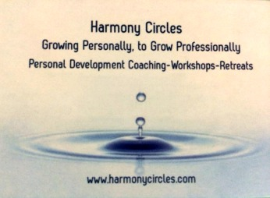
Harmony Circles
Personal & Business Growth
Mindset Checklist
Welcome to Harmony Circle’s Mindset Checklist!
This short and powerful assessment will help you identify foundational areas of your mindset that will impact your personal development and business growth. Email your completed responses to Brenda@HarmonyCircles.com to receive a complimentary coaching consult.

Personal Development
 | True | False
I have a clear sense of personal purpose.
I know my top values and how they relate to my life vision.
I have examined my thoughts & beliefs and release those that no longer serve me.
I am clear on what my current goals are physically, emotionally, relationally, financially and spiritually.
I am confident in my communication skills.
I have self-care habits that help me to sustain my mindset & energy.
I have professional support to help me continue to grow.

Business Growth
 | True | False
I have a clear vision for my business.
I have written down the values for my business & how they relate to my business vision.
I have examined my thoughts & beliefs regarding my business success, and release those that no longer serve me.
I know what I want to achieve in my business & regularly review my goals and progress.
The dynamics within my team support each person’s professional success.
I have the conflict management skills to effectively manage difficult situations.
I have professional support to help me continue to grow professionally.

Next Steps: Are there any specific next steps that you would like to take?
___________________________________________________

